Result-Based Performance Management System Calendar
C.Y. 2022
Non School-based Personnel

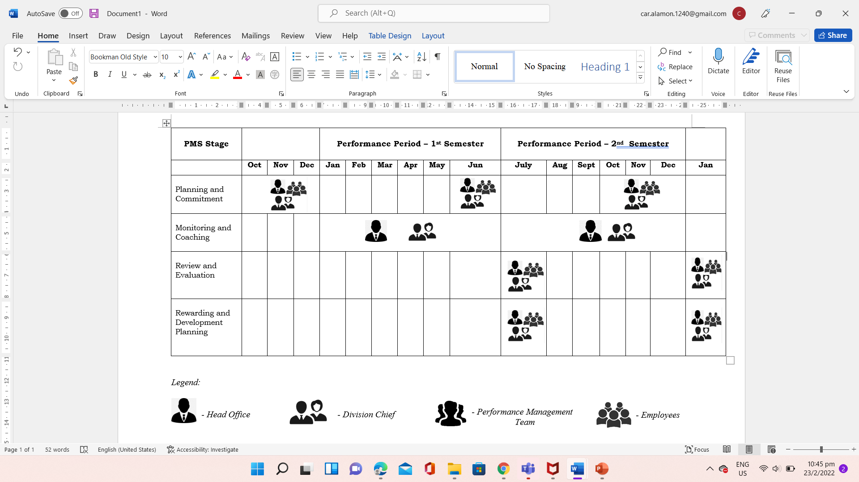

Result-Based Performance Management System Calendar
S.Y. 2022
School-based Personnel

